Cache Memory in Computer Organization

- Cache Memory is a special very high-speed memory.
- It is used to speed up and synchronizing with high-speed CPU.
- Cache memory is costlier than main memory or disk memory but economical than CPU registers.
- Cache memory is an extremely fast memory type that acts as a buffer between RAM and the CPU.
- It holds frequently requested data and instructions so that they are immediately available to the CPU when needed.
- Cache memory is used to reduce the average time to access data from the Main memory.
- The cache is a smaller and faster memory which stores copies of the data from frequently used main memory locations.
- There are various different independent caches in a CPU, which store instructions and data.
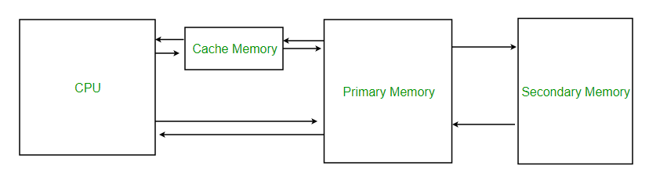
Levels of memory:
- Level 1 or Register –
It is a type of memory in which data is stored and accepted that are immediately stored in CPU. Most commonly used register is accumulator, Program counter, address register etc.
- Level 2 or Cache memory –
It is the fastest memory which has faster access time where data is temporarily stored for faster access.
- Level 3 or Main Memory –
It is memory on which computer works currently. It is small in size and once power is off data no longer stays in this memory.
- Level 4 or Secondary Memory –
It is external memory which is not as fast as main memory but data stays permanently in this memory.
Cache Performance:
When the processor needs to read or write a location in main memory, it first checks for a corresponding entry in the cache.
- If the processor finds that the memory location is in the cache, a cache hit has occurred and data is read from cache
- If the processor does not find the memory location in the cache, a cache miss has occurred. For a cache miss, the cache allocates a new entry and copies in data from main memory, then the request is fulfilled from the contents of the cache.
The performance of cache memory is frequently measured in terms of a quantity called Hit ratio.
Hit ratio = hit / (hit + miss) = no. of hits/total accesses
We can improve Cache performance using higher cache block size, higher associativity, reduce miss rate, reduce miss penalty, and reduce the time to hit in the cache.
The page table of the process is held in the kernel space. The kernel may have several page tables in RAM, but only one is the active page table. In x86 CPUs, it's the page table pointed by register CR3.

